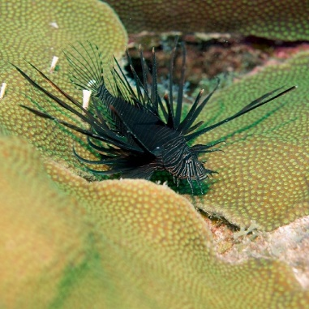
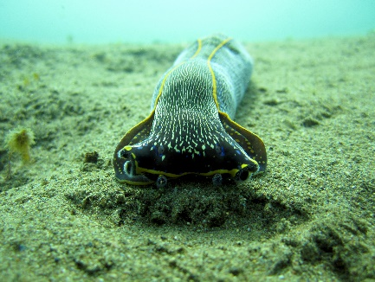

Banning High School
Mr. Steinriede/Mr. S
Room 222
Omniology.weebly.com
TheSisforscience@gmail.com
1527 Lakme Ave,
Wilmington, CA 90744
(310) 847-3700
Major assignments will be graded using a 4 point rubric. Rubrics are designed to allow students to show mastery of the California Content Standards and assignments graded with a rubric can be revised/re-done to allow the students to improve their grade (excluding finals). Assignments graded with a rubric include; notebooks, end of unit projects/tasks, lab reports, and current events.
Welcome to Marine Biology, this class will examine the different zones, habitats, and ecosystems that comprise our oceans. The different factors, living and nonliving which influence the organisms living with in these zones. We will be investigating the different phylum found in our oceans and the interesting organisms that belong to each.
Rubric Points | Point Value
4 | 100
3 | 85
2 | 65
1 | 50
0 | 0

This classes assignments will include: An interactive scientific note book, a scientific field notebook, class work, homework, tests/quizzes, and end of unit projects.
Grade | Percentage of total Points Earned
A | 100 % - 90 %
B | 89 % - 80 %
C | 79 % - 70 %
D | 69% - 55 %
F | 54% and below

Class Materials:
Everyday, each student must have:
- Pen and/or pencil
- Science Journal (a composition notebook, stored in class or taken home for completion)
- Science Notebook (any type of note book approximately 200 pages, lined, standard sized 8”x11”

Classroom Rules and Expectations:
- Be Respectful
- Respect each other
- Respect other opinions/thoughts
- Respect the classroom and equipment
- Be Safe
- Think before you act
- Follow safety procedures/directions
- Watch out for each other
- Be Professional
- Come to class on time and prepared
- Dress appropriately
- Put electronics and headphones away
- Take responsibility
- Be the best version of yourself
- Keep a positive attitude
- Always participate
- Encourage and help others

Behavioral Consequences:
Positive | Negative
1) Verbal Praise | 1) Warning
2) Class Recognition | 2) One on One Conference/seat change
3) Positive phone call home | 3) Behavioral Contract
 | 4) Phone call home
 | 5) Detention/Parent Conference

Plagiarism/Cheating
Plagiarism or cheating of any kind will not be tolerated and result in an automatic zero for the assignment. Plagiarism includes, but is not limited to, copying other student work, copying from the Internet, or copying from other books providing various information. Plagiarism will be determined by the teacher.
Office Hours:
I will have office hours after school on most days please email me to set up a conference. Thank you.
Acknowledgement of Mr. Steinriede’s Rules, Policies, and Procedures
Student Name (printed): ____________________________________________Period:
Students:
I have read the classroom policies and behavior expectations. I will honor them all throughout the 2016-2017 school year and understand the negative impact on my grades if I fail to comply.
Student Signature: __________________________________________________________________________
Date: __________________________
Parents:
I have read the classroom policies and behavior expectations and have reviewed them with my child.
Parent’s Name: ____________________________________________________________________________
Parent Signature: ___________________________________________________________________________
Main Language spoken at home:_______________________________________________________________
Day Time (cell) Phone Number: _______________________________________________________________
Evening Phone Number: _____________________________________________________________________
Best Time to call: ___________________________________________________________________________
Email address: _________________________________________________
Any Important information that I should know about your child. __________________________________________________________________________________________________________________________________________________________________________
Date: ____________________________
For special circumstances, please schedule a conference soon so that we can discuss your child’s pathway for success.

